Article ID: 1160
Article Name: How to remove lime scale in my washing machine
Topic Location: washing machine/Cleaning & Maintenance
Meta-data: lime scale, descale
Related Articles:
Related Questions:
PNC
DIY
Safety
Link
Email
Book Engineer
Multimedia
Brand
Article Content:
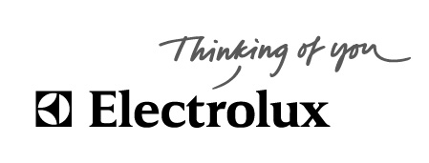

Why descaling washing machine?

Inside the drum may look nice and shiny, but of a washing calcified state should be viewed in
back of drum, which is not immediately visible.
If a washing heater is covered with lime, the machine has:
• Longer to heat up the water
• Energy consumption increases
• Heater life is significantly reduced
• The heating element can at worst burn out
• The machine's main bearings may be damaged

Water hardness is determined by the calcium and magnesium content. A large content provides hard water -
a small content provide soft water. The water content of calcium and magnesium is primarily due to supply
of these ions into the groundwater due to leaching of the soil layers above the aquifer.
In some areas the water hardness vary. This is because the area supplied with water
from several different water companies, depending on the current consumption. Click on your municipality
website and see the current hardness of your address, or call the technical department of your
municipality.
For safety's sake should be descaled after the highest value in your area.
Water hardness is given in ° dH (German degrees hardness).

Descaler for washing machines?

To achieve better performance and to protect the washing machine, we recommend descaling regularly with an Electrolux descaling product (see table)

 | Schedule for descaling frequency
Hardness in ° dH | Water hardness characteristics | <2 per wash. day | 2-4 per wash. day | > 4 per wash. day
0-4 | Very soft | - | - | -
4-8 | Soft | - | - | 1 time per. year
8-12 | Moderately hard | Every 6 month | Every 6 month | Every 6 month
12-18 | Rather hard | Every 6 month | Every 3 month | Every 3 month
> 18 | Hard | Every 3 month | Every 2 month | Every month

The frequency of indicative scaling is determined by the hardness and the number of wash cycles per. day.

Dosing instructions and user manual is with the descaling product.

Link to Electrolux descaling.:
Choose accessories & spare parts. Enter best.nr in the search box> search with keyword-Part no.
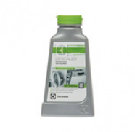
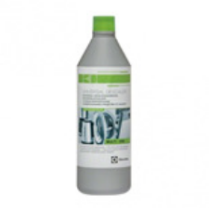
Liquid 1l. Cat.: 9029792984
Powder 200gr. Cat: 9029792257

